**Class 6 Lab questions**

#1. ternary conditional

Code:

#include <stdio.h>

int main()

{

    int a285,b285;

    a285= 10;

    printf("Value of b is %d\n",(a285==1)?20:30);

    printf("Value of b is %d\n",(a285==10)?20:30);

}

Output:

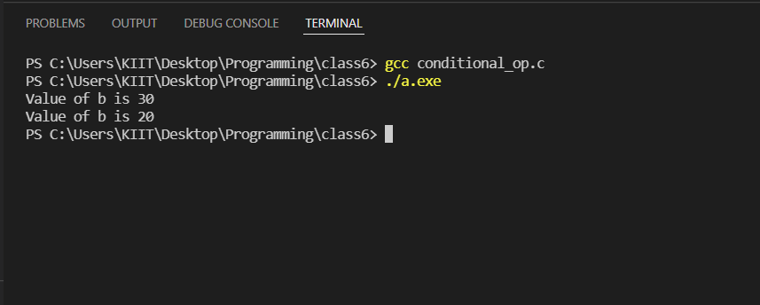

#2. Modifiers- Constant

Code:

#include <stdio.h>

void main()

{

const int height285 = 100;

const float number285 = 3.14;

const char letter285 = 'K';

const char letter_sequence285[10] = "KIDUS";

const char backslash_char285 = '\?';

printf("value of height %d\n", height285);

printf("value of number %f\n", number285);

printf("value of letter %c\n", letter285);

printf("value of letter sequence %s\n", letter_sequence285);

printf("value of backslash character %c\n", backslash_char285);

}

Output:

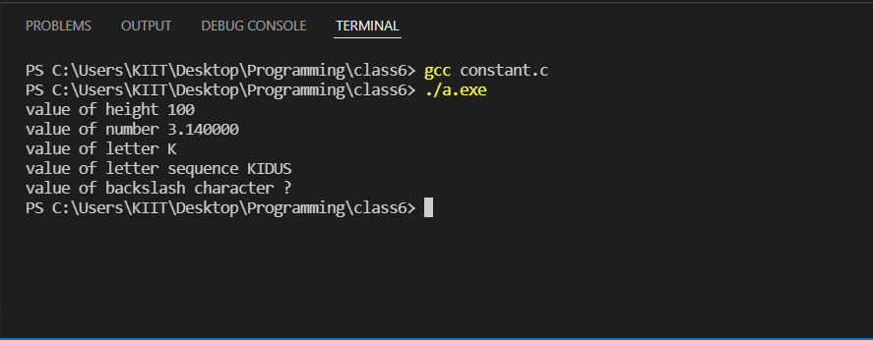

#3. Special Operations

Code:

#include <stdio.h>

int main()

{

int a285=21;

int c285;

c285=a285; printf("Line 1- = Operator example, value of c=%d\n",c285);

c285+=a285; printf("Line 2- += operator example, value of c=%d\n",c285);

c285-= a285; printf("Line 3- -= operator example, value of c=%d\n",c285);

c285*=a285; printf("Line 4- *= operator example, value of c=%d\n",c285);

c285/=a285; printf("Line 5- /= operator example, Value of c=%d\n",c285);

c285=200;

c285%=a285; printf("Line 6- %= operator example, value of C=%d\n",c285);

return 0;

}

Output:

